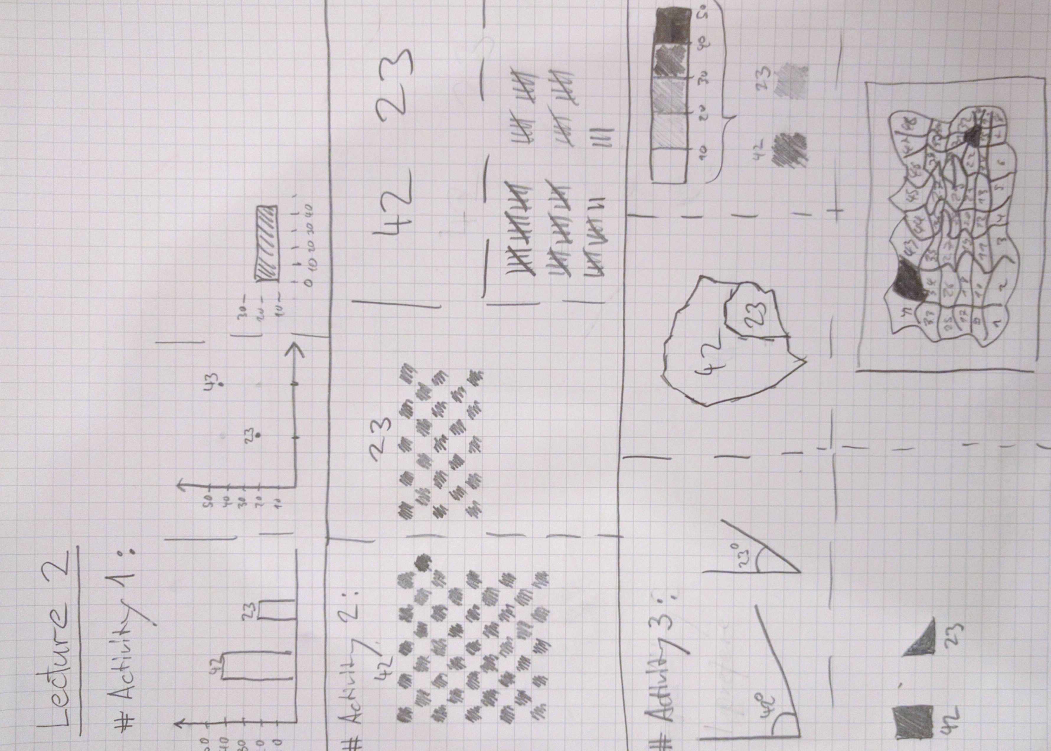

**# Activity 4**

I prefer visualization B. It’s much easier to get the raw information out of it. This is because it’s easier to compare length than sizes. Furthermore, the overlapping areas make it near impossible to compare the salaries by size. It is also helpful that the right graph is sorted according to size while the left isn’t.

**# Activity 5**

What question does this visualization answer?

* How much time is spent in the browser vs. the app ecosystem on smartphones.

What marks and channels are used?

* Areas, colors, numbers

Does it violate Tufte’s design pricnciples? Which ones?

* Yes, first of all, according to tufte the pie chart / donugh chart is never the best kind of visualization. With less ink more information can be transported. Furthermore, the human eye is much better in comparing length to sizes.

Why do you like/dislike this visualization?

* I dislike the graph. It is actually not that easy to get the information out of it. The main message is, that Apps are more used that the browser. However, with that information I don’t need the other numbers.

**Better version of the graph**